Digital Parking Management System for Dhaka City
Based on Wireless Sensor Network

Didarul Amin,Nazrul Islam,Md.Abdul Gaffar,Innika Khatun,Meheruj Akter,Amena Khatun, Sumiya Rashid Mim
Dept. of Computer Science and Engineering
International University of Business Agriculture and Technology
Uttara,Dhaka,Bangladesh
didarul38@gmail.com

Abstract— In this paper, we present the design and development of a Digital parking system using the latest technologies based on wireless sensor networks (WSN) in order to solve existing car parking problem in Dhaka city. Our system uses an adaptable and hybrid self-organization algorithm for wireless sensor networks that adapts to all types of car parks existing in the city (linear and mass parking), and offers a better management of the energy consumption during the wireless communication to increase the lifetime of the sensor nodes and the longevity of the WSN. This system also offers innovative services, which facilitate the task to the drivers when looking for an available parking space in the city near their destination, in a fast and efficient manner.
Keywords: parking system; smart parking; wireless sensornetworks;RFID(radio-frequency
identification)

Introduction

Over the decades, Dhaka city has been developing very fast, now we are in this state that we have a lot of well-constructed roads, commercial building and increasing number of automobiles. While parking these automobiles in parking space we use the manual procedure of parking. Which most of the cases is unplanned and lack of discipline due to this, people can park their cars anywhere they want to, which creates a mess, as people do not follow the particular sign most of the time. Because of this, a huge traffic jam takes place in that place. While parking in and retrieving car due mismanagement cars can get damage by bumping with each other, as there is lack of sufficient space. This leads to arguments, fights among people, which sometimes makes huge traffic jam. This is also an economical loss as we need to repair our damaged car and cars consumes extra fuel while parking in out. Traffic jam is an issue here as it kills our precious time. Due to this chaos in parking, our valuable time is wasted. It harms the students, office going staffs and emergency patients largely. Due to the lack of proper parking, most people park their cars in the street. In addition, if you do not have a driver with your car, then you would want to park it close by. Moreover, wherever you parked, it might be a fined by the police for hindering the flow of traffic.
Traditional or manual car parking system is everywhere in our country but this system is full of problems.

- We can see in many shopping malls, hospitals huge traffic jam in front of the parking. The parking guard stops the entire vehicle and gives a payment slip this creates traffic jam.
- It is difficult and time consuming to find out the parking slot, which costs extra fuel and wastes time.
- Security problem is one another problem in manual car parking, people can enter in parking slot and there snatching, robbery can happen.
- In manual parking system, some guard needs to be appointed for the whole job, it is costly enough.

Therefore, we need a solution, which can overcome these problems. Here this paper proposing Digital Parking Systems as a solution of parking problems in Dhaka city as well as car parking management system for Dhaka city based on wireless sensor network. This system will replace manual parking system of parking lots or garages. This system not only helps in saves time and money or reduce traffic jam; it can also earn money by charging for parking spaces.
The organization of this paper is as follows. In section II we focuses on the related work topics. In section, III the Architecture of proposed system based on wireless sensor network is introduced. In section IV contain conclusion.

Related Work
Vipin Kumar verma,[6], proposes distributed traffic monitoring and controlling model using sensors and dedicated traffic servers. This model is described as basic role-oriented processes communicating though primitive interaction protocols. The model is aimed to provide an enabling communications framework upon which multi agent system models can be organized and built to be used for an simulation of an road map and to estimate the traffic behavior (to provide information about the best routes). The model assists the drivers to get the desired destination taking into account the current situation of traffic characteristics. It gives the estimated arrival time and the corresponding distance between a start and an arrival point. The necessary information is obtained from current traffic position using sensors (used as dynamic information and to characterize the traffic, for example if traffic is jammed on an area, we can predict alter paths). The information given by the advisory system has the form of self-generated message according to the condition of traffic using the given algorithm.
Seong-e-yo,[5], proposed DGS, a Driving Guidance System based on wireless sensor networks(WSN) which guides a driver to drive a car in safety. The system consists of two sub-systems: SMS(Speed Measurement Sub-system) and WPS(Weather information Providing Sub-system). SMS measures the speed of a car and captures the image of the speeding car using a speed camera. WPS provides weather information including the road conditions (icy,wet, etc.) via VMS or a telemetric terminal. Abbreviations and Acronyms
.S. V. Srikanth, [4], proposed a Smart Parking (SPARK) Management System, which provides advanced features like remote parking monitoring, automated guidance & parking reservation mechanism. Though prototype system, they proposed the architecture which satisfies the car parking management system requirement.
Mingkai Chen, [1], introduces a parking guidance and information system based on wireless sensor system. This system consists of parking space monitoring nodes, routing nodes, sink node, parking guidance display and an information and management center. The nodes transmit the information through wireless sensor network by treelike topological structure with non-standard protocol we developed. After analyzing and processing the data, the information and management center would distribute the parking information by LED screen and displays for the drivers. In addition, the results of the experiment show that the performance of the system can satisfy the requirements of parking guidance.
Europe, the United Kingdom and Japan were among the first countries to implement smart parking systems. Today we can find several smart parking facilities in most major cities. Smart parking technology benefits the customer and the parking operator in the following ways:
- The customer can readily determine space availability prior to entering the garage and/or parking level.
- The customer can plan for their transit to public transportation with such smart parking systems employed at Park and Rides
- The parking operator can use the system data to develop or improve pricing strategies.
- The parking operator can use this system data to predict future parking patterns and trends.
- The parking operator can use this system data to prevent vehicle thefts.
- The parking operator can reduce the staffing requirements for traffic control within the facility.
- The system significantly reduces traffic–and the resulting vehicle emissions– by decreasing the time required customers to locate open spaces.

SYSTEM ARCHITECTURE
The proposed system contains three essential parts: parking detection Centre, parking monitoring Centre, and information management Centre.
- The parking detection Centre is composed mainly of hybrid sensor node that are installed in each parking space in each area, these sensor nodes form a wireless sensor network (WSN) allowing to collect the states of all the parking spaces (available or occupied) to send them to the gateway (Sink) of this area, this information will be sent afterwards to the central server to store them in the global database
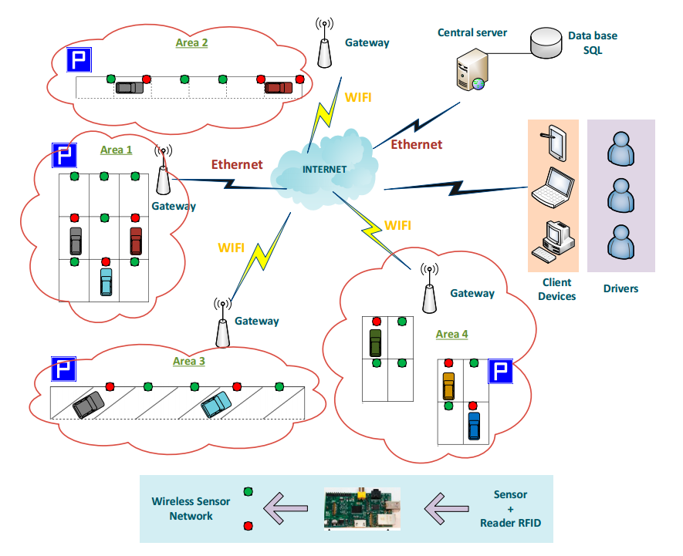
Figure: Proposed parking management System for Dhaka City
- The parking-monitoring Centre is responsible for identifying and checking the cars that have just parked in a reserved or available space. This center uses the RFID technology to control and monitor the one hand the parked cars and the other hand, for identify and manage the payment of parking time.
- The global information management center is a database where all information detected and collected from all car parks in the city is recorded and prorogated in real-time by web or mobile applications. In this way, drivers will have all the information on the available spaces in all the car parks of the city, to consult these spaces according to their destination, and to pay the parking fees.

PARKING DETECTION CENTRE
The parking detection center uses two very recent technologies, wireless sensor networks (WSN) and RFID technology. The formation of the sensor network changes according to the type of parking in the area. For linear car parks, a chain topology formed in the network and, on the other side for mass car parks, a cluster topology formed in the network.

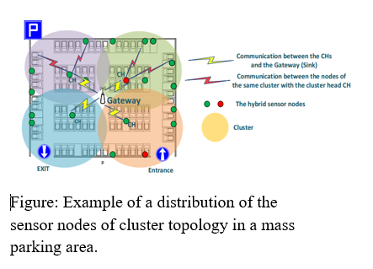

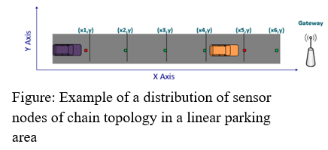

Parking Monitoring Center
The parking-monitoring center uses wireless sensor networks (WSN) and integrated RFID
technology in these sensor nodes installed in each parking space. RFID technology is a technology based on radio frequency identification that helps to check and identify objects by radio waves. Thus, vehicles identified and parking fees collected via this system, to manage and monitor the parking area in an efficient and convenient manner.

Algorithm of managing the parking space in each area, when a vehicle arrives in the parking area.
- When a car stand on parking space then sensor node change its initial value and sent to Gateway.
- Update the information received from sensor node in the database.
- Increment the number of occupied spaces.
- Decrease the number of available space.
- RFID tag is detect of car then update occupied space with RFID data received in the database.
- Send a message about detected RFID tag number of car to the database through parking agents.
- Start counting the parking time of car with RFID tag number.

Algorithm of managing the parking space in each area when a vehicle leaves the parking area.
- When a car leave parking space then sensor node changes it’s previous value and sent to Gateway.
- Update the information received from sensor node in the database.
- Decrease the number of occupied spaces.
- Increment the number of available spaces.
- Save the time when the car left the parking space.
- Stop parking time.
- While the parking payment is not performed wait for 15 min else
- Send a notification to the authorities with the registration number of the car for a fine
- Update the database with the available state of the space.

GLOBAL INFORMATION MANAGEMENT CENTRE

The global information management center relies on the data stored in the database to develop extra services to the users and drivers by facilitating the task of searching for an available space in their destination, such as the consultation of the available parking spaces, the navigation to these spaces, and the online payment of parking fees. A mobile application developed that allows drivers to take advantage of these services in a practical and simple manner.

Consultation of parking areas:
Drivers use the mobile application that allows them to consult and find open parking spaces near their destination, before moving to avoid unnecessary travel and not to create congestion of traffic. This application uses the information that is stored in the database to make available to drivers, the open parking areas closest their destination with the number of available and busy spaces in real-time, by indicating the parking price

Navigation to parking areas:
This service is based on the use of Google MAP to orient and guide drivers towards the desired parking areas. The driver opens the mobile application to look for an open parking near his destination. Then, depending on the results displayed by the application, the driver selects a parking area and the app opens Google MAP to guide the driver to the selected area. Once arriving in the area, the application displays the available spaces and busy squares in this parking area.

Payment of parking fees:
Before leaving the parking space, the driver must pay the parking fees; this payment is made either manually by moving to the automated teller machine of the parking lot by entering the number of vehicle registration. Either online, the driver uses the same mobile application with the same manipulations of the automatic teller machine to realize the payment of the parking fees in this parking area.

Algorithm for navigation to the parking area.
- Open the mobile application
- Introduce destination
- Display the closest parking areas with their prices
- The user selects the desired parking area
- While (No available space in the selected area)
- Navigation to the other area
- While (The driver did not arrive at the area)
- Display available and occupied spaces

Algorithm for parking fees via a mobile.
- Open the mobile application
- Realize the space payment
- Insert the registration number of your car
If (The registration number of the car exists in the database) then
- Display parking fees with information of the parking space in the area
- Pay
- Else
- The registration number of the car does not exist
- Contact the authorities
- End if

CONCLUSION
Above proposed system, digital car parking and management system can be introduce in our Dhaka city and it will be beneficiary in the context of our country. The main benefits are time and fuel saving. It can also provide sustainable parking management in an eco-friendly manner. As the Greenhouse gas, emission will be less in amount and the surroundings will be clean. There is less maintenance cost for this system so it is helps the property developer in cost saving. It provides security to the parking ground. Digital car parking systems reduce the hassle in parking grounds and traffic jam. It will benefit the property developer to increase their revenue, which will add to the government tax revenue. Therefore, in a way it is also helping the government by increasing tax revenue. It will also encourage Automation Engineering in our country, which will make advancement in increasing usage of technology. Therefore, we should introduce Digital car

References

[1] thedailystar.net, The Smartest Ways To Deal With Traffic Congestion in Dhaka‘, 2016. [Online]. Available:http://www.thedailystar.net/op-ed/politics/the-smartest-ways-deal-trafficcongestion-dhaka-1220956 [Accessed: 16- Nov- 2018].
[2] academia.edu, Managemental causes of traffic congestion in Dhaka city and its possible solution‘,2017.[Online].Available:https://www.academia.edu/30649982/Managemental_causes_
of_traffic_congestion_in_Dhaka_city_and_its_possible_solution?auto=download [Accessed: 16- Nov- 2018].
[3] academia.edu, Automated car parking system. [Online].Available:https://www.academia.edu/30649982/Automated_car_parking_system.?auto=download [Accessed: 16- Nov- 2018].
[4] thedailystar.net, Car parking Crisis in Dhaka‘, 2016. [Online]. Available:http://www.thedailystar.net/op-ed/politics/car_parking_crisis_in_dhaka [Accessed: 8- Nov- 2018].

- [6]. Vipin Kumar Verma, Rahul Chaudhari, Siddharth Kumar Singh,
Tapas Mishra, Pankaj Srivastava , “Intelligent Transport Management
System using Wireless Sensor Networks”, IEEE Intelligent Vehicle
Symposium Elndhoven University of technology Elndhoven,
Netherlands, June 4-6, 2008.
- [5]. Seong-eun Yoo, Poh Kit Chong, Taehong Kim, Jonggu Kang,
Daeyoung Kim, Cahngsyb Shin, Kyungbok Sung, Byungtae
Jang,“PGS: Parking Guidance System based on Wireless Sensor
Networks”, 978-1-42441653-0/08, 2008 IEEE.
- [4]. S. V. Srikanth, Pramod P. J., Dileep K. P., Tapas S., Mahesh U. Patil,
Sarat Chandra Babu N, “Design & Implementation of a Prototype
Smart Parking(SPARK) System using Wireless Sensor Networks”
International Conference on Advanced Information Networking &
Applications workshops, 978-0-7695-3639-2/09, 2009 IEEE.
- [1]. Mingkai Chen, Tainhai Chang, “A Parking guidance & Information
system based on Wireless Sensor Networks”, IEEE International
Conference on information & Automation Shenzhen, China, June
2011.

